Code:

appliaction.yml

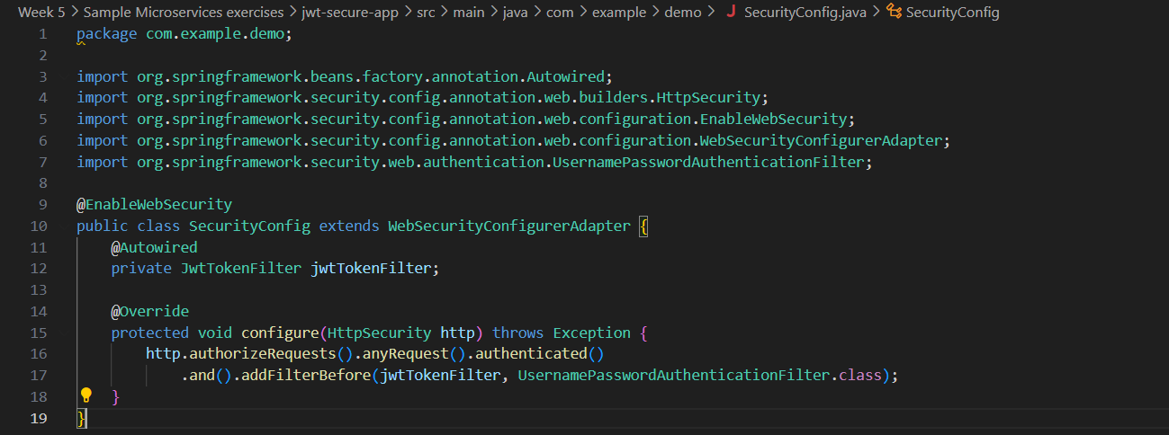SecurityConfig.java

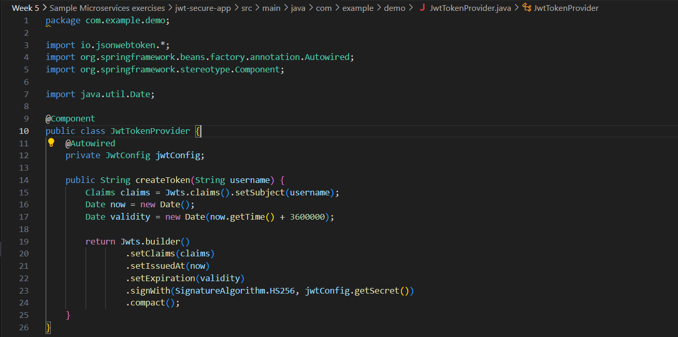JwtTokenProvider.java

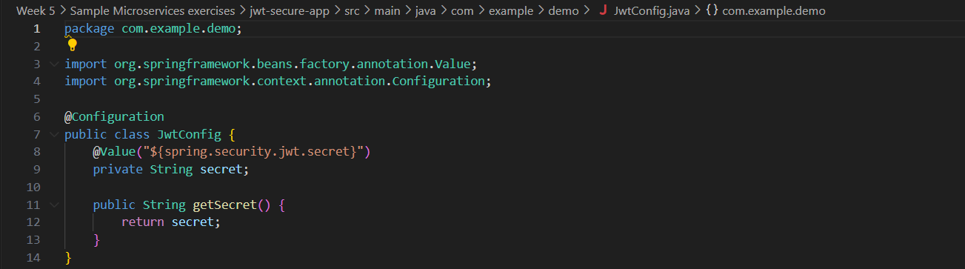JwtConfig.java

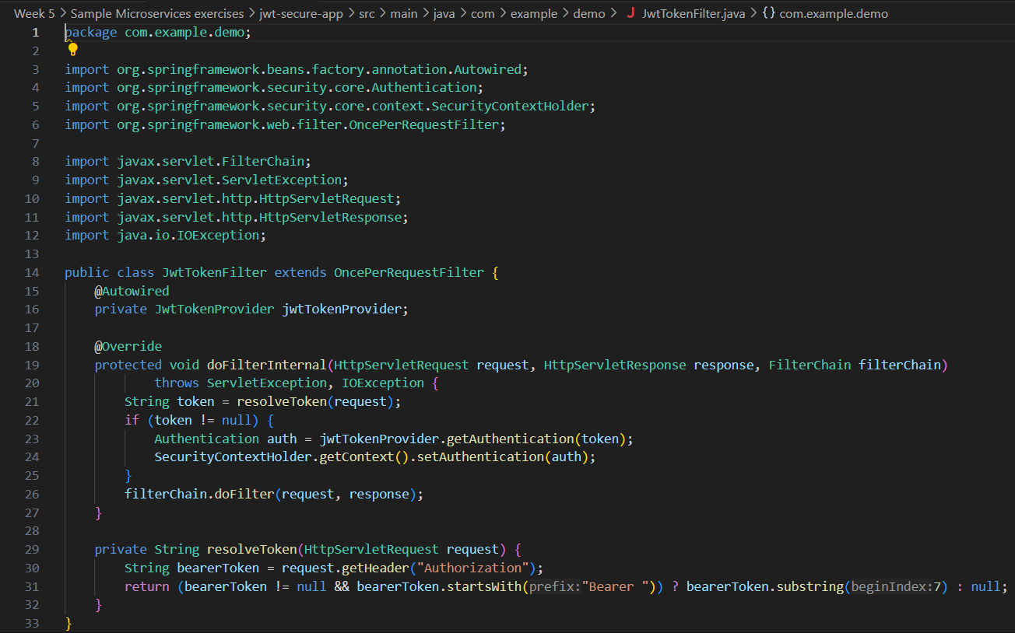JwtTokenFilter.java